Social Change Model of Leadership (7 C’s)
The Office of Student Organizations and Leadership has chosen to model Leadership Initiatives for the 2019-202 0 school year after the Social Change Model:
*Established in 1994, the Social Change Model of Leadership Development approaches leadership as a purposeful, collaborative, values-based process that results in positive social change. The Social Change Model is sometimes called the seven C’s for Change because it espouses seven values of leadership that occur on three dimensions with the goal of positive social change (the eight “C”)*
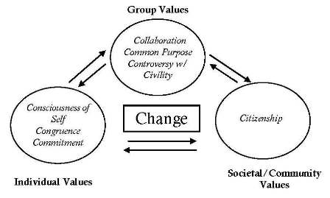

Consciousness of Self
Awareness of the beliefs, values, attitudes, and emotions that motivate one to take action. This is the key to being able to develop consciousness of others.

Congruence
Thinking, feeling, and behaving with consistency, genuineness, authenticity, and honesty towards others; actions are consistent with most deeply-held beliefs and convictions; interdependent with Consciousness of Self.

Commitment
The psychic energy that motivates the individual to serve and that drives the collective effort; implies passion, intensity, and duration, and is directed toward both the group activity as well as its intended outcomes; requires knowledge of self.

*Collaboration*
To work with others in a common effort; constitutes the cornerstone value of the group leadership effort because it empowers self and others through trust; leadership as a group process; encourages group to transcend individual goals, interests and behaviors; vital that group members explore differences in individual values, ideas, affiliations, visions and identities.

Common purpose
To work with shared aims and values; facilitates the group’s ability to engage in collective analysis of issues at hand and the task to be undertaken; best achieved when all members of the group share in the vision and participate actively in articulating the purpose and goals of the activity.
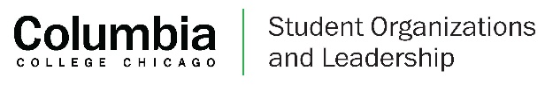

Controversy with civility
Recognizes two fundamental realities of any creative group effort: that differences in viewpoint are inevitable, and that such differences must be aired openly, but with civility. Civility implies respect for others, a willingness to hear each others’ views, and the exercise of restraint in criticizing the views and actions of others. Requires trust amongst the group members; conflicts need to be resolved but also integrated into the common purpose.

Citizenship
The process whereby an individual and the collaborative group become responsibly connected to the community and the society through the leadership development activity. To be a good citizen is to work for positive change on the behalf of others and the community. The practice of good citizenship should and needs to happen at every level of the model.

Change (*The Eighth C)
The ability to adapt to environments and situations that are constantly evolving, while maintaining the core functions of the group. Change is the value “hub” which gives meaning to the 7 C’s and is the ultimate goal of the creative process of leadership – to make a better world and a better society for self and others.
Leadership Sponsored Fall 2019 Events:
September 20th - Designing Your Career – Career Center 10:00am – 11:30am
September 27th, 10:00am – Noon: Hope For The Day (HFTD) (SAA, Counseling Services)
September 30th – October 4th: TRIO Week Events (more information to come via e-mail)
October 4th - CODE: Cultural Opportunities and Diversity Expo (Career Center) – 11:00am – 2:00pm
October 11th, 3pm – 4pm: Mental Health & Leadership (Counseling Services)
October 23rd, Spill the Tea on Identity (Student Diversity & Inclusion)
November 6th, How to Nail Every Job Interview (Career Center) – 4:00pm – 5:00pm
November 20th, Self Care (Student Diversity & Inclusion)
December 13th, Healthy Holiday Potluck (SAA)
January 31st, 4pm – 6pm: New Years & Wellness Check (SOL & SAA)
Please reach out to leadership@colum.edu
to provide suggestions or ask any questions regarding leadership initiatives
More Information about Social Change Model can be found:
https://drexel.edu/studentlife/get_involved/leadership_development/About/social-change/

