PRODUCED BY STUDENT ACTIVITIES

STEP
1
DEVELOP YOUR EVENT

Great planning is essential to the success of an event. As you begin the brainstorming process, use the prompts below to determine the scope and goals of your event.

What is the purpose of our event?

How does it tie to the mission of our organization? What do we hope to accomplish?
Who is our targeted audience?

How will the campus community benefit from the event?

Do we want to collaborate with other student organizations, college departments or outside partners? How will they enhance our event and what will our individual roles be as collaborators?

Who are potential event participants, such as vendors, sponsors or talent?

What is our budget for this event and can it support everything we want to do?

How will we engage our volunteers or board members when planning, promoting and hosting our event?

CREATE AN EVENT SUMMARY
Create a concise summary describing the purpose and what will happen your event. This description can be used when you make a space reservation through the Campus Space Scheduler in Step Four.

STEP
2
CREATE A BUDGET

Creating a budget is one of the first steps when planning an event. Before you make any purchases or sign any contracts, make sure have enough funding to pay for everything you want to do…and enough left for future needs!

POTENTIAL EXPENSES MIGHT INCLUDE:
Food/catering/refreshments, marketing expenses (posters, ads, t-shirts, giveaways, etc), event supplies and decorations, venue rentals, performer fees, hospitality, thank you gifts, independent contractors (ASL interpreters, photographers, videographers). Information about technical costs, additional security and building extensions is located in Step Five.

POTENTIAL REVENUE MIGHT INCLUDE:
Allotted budget, donations, fundraisers, sponsorships.

SPONSORSHIPS
Sponsorships are a great way to enhance your event and help you stay within your budget. It is also a great way for businesses to gain exposure for their brand on our campus. Work with your advisor and team to determine the best way to approach and negotiate with a potential sponsor.

If you obtain a sponsorship, it is important for us to communicate this with the Development Office. They keep a database that tracks financial and in-kind donations. This database could be really helpful in obtaining your donation. Perhaps you want to ask a specific business for two dozen cupcakes for your event. The Development Office will be able to tell you if the college has an existing relationship with them and other helpful info that could assist in getting those cupcakes!

If you obtain a sponsorship, work with Student Organizations & Leadership to record your gift. The Development Office will send your sponsor a thank you letter on behalf of the college acknowledging their generosity!

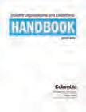You can use the Event Budget Template to track your budget located at the end of this

Student Organizations: check out the “Financial Information” section of the Student Organizations & Leadership Handbook for fundraising guidelines.
section.

PAYING FOR YOUR EVENT
If you are hiring talent for your event, please be sure to follow the steps below to make sure they are treated professionally.

Student Organizations should visit “Student Organization Proposal” section of the Student Organizations & Leadership Handbook for information on securing funding and accessing your account.

- SECURE A CONTRACT
If you are hiring talent (such as DJs, hosts, performers, photographers, etc), work with your advisor to ensure there is a contract in place that outlines the responsibilities for all parties involved. Student Organizations & Leadership will sign off on all contracts.

- OBTAIN AN INVOICE
Hired talent must submit a signed invoice in order to receive a check. Include the address they want the check MAILED to and them know it takes 3 – 4 weeks to process. Submit invoices to Student Organizations & Leadership. If the Independent Contractor is a student worker, tell Student Organizations & Leadership, as their payment will be processed differently.

Use the Independent
Contractor Agreement provided by the college’s General Counsel department located at the end of this section.

EVENT BUDGET SHEET
TOTALS ESTIMATED | ACTUAL | DIFFERENCE
TOTAL EXPENSES
TOTAL INCOME
TOTAL PROFIT/LOSS

EXPENSES INCOME
ALLOTTED BUDGET ESTIMATED | ACTUAL | DIFFERENCE
DONATIONS ESTIMATED | ACTUAL | DIFFERENCE
SPONSORSHIP ESTIMATED | ACTUAL | DIFFERENCE
GRANTS ESTIMATED | ACTUAL | DIFFERENCE

VENUE/SPACE | ESTIMATED | ACTUAL | DIFFERENCE
Rental
Venue Staff
building Extensions
Additional Security
Furniture Rental
Other
Subtotal
FOOD | ESTIMATED | ACTUAL | DIFFERENCE
Food
Beverages
Linens/Dishes/Utensils
Other
Subtotal
MARKETING | ESTIMATED | ACTUAL | DIFFERENCE
Graphic Design
Printing
Advertisements
Subtotal
TALENT | ESTIMATED | ACTUAL | DIFFERENCE
Performers
Speakers
Travel
Hotel
Other
Subtotal
DECORATIONS | ESTIMATED | ACTUAL | DIFFERENCE
Flowers
Balloons
Paper Supplies
Lighting
Other
Subtotal
TECHNICAL FEES | ESTIMATED | ACTUAL | DIFFERENCE
Sound
Lighting
DJ Services
Equipment Rentals
Other
Subtotal
MISCELLANEOUS | ESTIMATED | ACTUAL | DIFFERENCE
Insurance/Permits
Transportation/Parking
Other
Subtotal
TOTAL EXPENSES

INDEPENDENT CONTRACTOR AGREEMENT
This Agreement (“Agreement”) is entered into this day of 20 , between Columbia College Chicago (“College”), an Illinois not‐for‐profit organization, with offices at 600 South Michigan Avenue, Chicago, Illinois, and Independent Contractor identified below.

IN CONSIDERATION of the mutual promises set forth herein, and for other good and valuable consideration, the receipt of which is hereby acknowledged, College hereby engages Independent Contractor to provide Service(s) upon the following terms:

Independent Contractor Information

  - Independent Contractor’s Name:

  - Address:

  - Social Security No. or Employer ID:

  - Phone Number:

  - Service Information
  - Description of Service

  - Date(s) of Service:

  - Time(s) of Service:

  - Approximate duration of Service:

  - Place of Service:

  - If applicable, the following provisions are also included in this agreement:

It is agreed that the set‐up for the service(s) will begin at

(time).

It is agreed that a sound check will take place promptly at (time).

3.0 Service Fee: College agrees to pay Independent Contractor $

( DOLLARS) for Service as identified in paragraph 2.0 upon completion of service(s).

4.0 Meals, Transportation, Lodging: Included in service fee.

5.0 Dressing Room: College shall provide a dressing room to Independent Contractor, upon request.

6.0 Promotion of Service: College will provide on‐campus promotion of service. Independent Contractor may also promote service at its own expense.

7.0 Merchandising: College shall provide an appropriate location and table for the sale of Independent Contractor’s merchandise. One hundred percent (100%) of receipts shall go to Independent Contractor.

8.0 Recordation of Service: College agrees not to authorize the broadcasting, recording, or reproduction by any means of Independent Contractor’s service(s) without the Independent Contractor’s consent. It is understood and agreed that this is a live service and that the only recordings that will be made of Independent Contractor’s service(s) will be used solely for archival and educational purposes.

9.0 It is understood and agreed that Columbia College Chicago regulations forbid the use of alcoholic beverages and/or other illegal substances while on College property. Violation of this regulation by the Independent Contractor or any of its associates may result in forfeiture of payment.

10.0 Insurance: College maintains insurance on the place of service. College assumes no responsibility for any property of the Independent Contractor brought in or about the premises, and College is hereby released from all liability for any loss or damage to the property of the Independent Contractor sustained by reason of occupancy of the premises.

11.0 Security: College will provide security during the Service. In the event Independent Contractor desires security guards or other such services, at times other than during the service, at Independent Contractor’s expense, special arrangement may be made with College.

12.0 Force Majeure: In the event that either College or Independent Contractor are unable to fulfill their obligations due to damage or destruction of the place of service by fire, verified disability of Independent Contractor, acts or regulations of public authorities, labor difficulties, civil tumult, strike, epidemic or any unforeseen occurrence rendering the service(s) impossible, neither Independent Contractor or College shall be held legally responsible for any damage arising from the cancellation of the service(s).

13.0 Indemnification: Independent Contractor shall so use the premises as not to endanger any person and Independent Contractor agrees to protect, indemnify, hold harmless and defend College from any liability, damage or expense incurred by reason of injury or injuries sustained by anyone to persons or property or loss of property received, done or occurring in or about the premises, excluding that caused by or resulting from the negligence of College.

14.0 Assignment: This Agreement, and compensation payable under the terms hereof, cannot be assigned or transferred without the mutual written consent of Independent Contractor and College, and contains the complete understanding of the parties respecting the subject matter hereof.

15.0 Relationship: The parties hereto are independent contractors. Nothing in this Agreement shall be understood or construed to create or imply any relationship between the parties in the nature of any joint venture, employer/employee, principal/agent or partnership. Independent Contractor shall not become an employee of College by acting under this Agreement and Independent Contractor shall be responsible for the payment of any taxes and social security contributions owing from the above compensation.

16.0 Modification of Agreement: It is understood and agreed that this Agreement may not be changed, modified or altered, except by mutual agreement of both parties. All changes to the contract for this engagement must be initialed by authorized signatories of both parties OR changes may be implemented via a separate written document signed by both parties.

17.0 Governing Law: This Agreement shall be governed by and construed in accordance with the laws of the State of Illinois.

  - Cancellation Policy: If Independent Contractor cancels service, no payment shall be made to Independent Contractor. If College cancels service, reasonable attempts will be made by both parties to reschedule service; otherwise Independent Contractor will be paid in‐full.

Each of the parties hereto has caused this Agreement to be executed by a duly authorized representative as of the date first written above.

COLUMBIA COLLEGE CHICAGO INDEPENDENT CONTRACTOR

BY:
BY:

DATE:

DATE:

STEP
3
CHOOSE A SPACE

Our campus spaces offer different features so it is important to think about what is the most appropriate space for your event. Use the prompts below to help deter- mine what kind of space works best for your event.

APPROPRIATE SPACE:
How many people do we anticipate attending?

What is the capacity of the space we want to use? (Note – capacities differ depending on set-up!)

Is the address/location of space important? Is proximity to another location necessary?

SPACE SET-UP:
Are we having a dance party and need open space for movement? Do we need theatre style chairs for a screening?
Do we need tables for food and refreshments? What are the furniture policies for each space? Are we allowed to reconfigure/move the furniture?
How will we decorate/transform the space to achieve our programming goals?

TECHNICAL REQUIREMENTS:
Does the space have the necessary technical capabilities to support our event? Does our talent need backline to perform and do we have what they need?
Do we need to provide a stage plot for our event?

STUDENT SPACES
The Department of Exhibition and Performance Spaces are common areas where students can interact, relax, and socialize. DEPS facilities are entirely supported by the Student Activity Fee and are only available for student-centered programming. Events must be free and open to Columbia College Chicago students.

Review capacity information, technical capabilities, furniture availability and floor plans for each of the student spaces at the end of this section.

DEPS STUDENT SPACES INCLUDE:

Conaway Center
1104 S Wabash Ave, first floor

Stage Two Center
618 S Michigan Ave, 2nd floor

HAUS, located within the Quincy Wong Center for Artistic Expression
623 S Wabash Ave, first floor

Film Row Cinema
1104 S Wabash, 8th Floor

IMPORTANT REGULATIONS FOR ALL DEPS SPACES

Only 2 events per semester, per student or student organization No open flames or candles
Fog machines are prohibited on campus

No animals, fish, or insects are allowed in DEPS facilities

Faculty advisor or college representative must be present for the entire event Events must be free to current Columbia students
The student organization or college representative booking the event is responsible for the setup and cleanup of the event and any damage made to the space.

Flyers for events must be posted in designated areas around campus. Flyers posted on the walls, columns, and lobby areas of DEPS spaces may be removed at the discretion of DEPS staff.

Space requests more than 6 months in advance will be marked as "tentative" and are subject to further review closer to the event date.

Spaces must be left in the condition in which they were found. No holes in the walls, and no painting. Any adhesives used must be non-residue stickies, such as Fun-Tak, 3M hooks or blue painters tape.

1104
S. WABASH
CONAWAY CENTER

SUMMARY
W. VAN BUREN ST.
W. CONGRESS ST.
W. HARRISON ST.
CTA
E. BALBO ST.
W. POLK ST.
W. 8TH ST.

W. 9TH ST.
W. 11TH ST.
W. ROOSEVELT ST.
CTA
S. STATE ST.
S. WABASH ST.
S. MICHIGAN AVE.
The Conaway Center is an open layout, multipurpose events space and student hangout area. The space has an open floor plan, making it customizable for many types of events. Appropriate events include concerts, dance, theater, panel discussions, job fairs, conferences, and fashion shows.
W A B A S H A R T S C O R R I D O R

Important Note: The Conaway is an open space for students at all times. We do not block the space off for rehearsals, soundchecks, or private events. Please keep in mind that any activities that are planned in this space may be witnessed by members of the Columbia community and that DEPS will not approve requests to block off the space for privacy.
P
A
R
K

CAPACITY
T
379
A
N

FURNITURE
G
R
The room currently has 8 – 36” round highboys with (3) stools each, (30) 36” square tables and (300) stacking chairs.

HOURS
The Conaway Center is subject to the normal building hours of 1104 S. Wabash. Please visit students.colum.edu/space for the most up to date building hours.

CONAWAY TECHNICAL SPECIFICATIONS

CONSOLE
Allen & Heath GL2400 4 Buss - LR main outputs - (6) aux sends pre/post switching - (4) audio groups – 4-Band, 2 mid sweep EQs

CONFIG
24 channel snake, 4 stage monitor mixes via FOH, 2 stereo channel effect returns

FOH EFFECTS
(1) – Lexicon MPX 500 (1) – Yamaha REV500

FOH PROCESSING
Compression - Presonus ACP88 (8) Channels of compression/gates, Klark Teknik DN 360 FOH Stereo Graphic EQ, (2) DBX 231 stereo 31 band Graphic EQ

MAIN SPEAKER SYSTEM
(4) - EAW MK2394 Mid/Hi Cabinets (4) - EAW SB180 Bass Cabinets Send from stereo two bus) Main Stereo Processor: DBX Drive Rack PA Processor (2-way Xover)
Main Power Amps: (1) QSC RMX 2450 (Highs), (1) QSC RMX 4050HD (Lows) Monitor Power Amps: (2) QSC 1400 (4 separate stage monitor mixes) Wedges: (4) Yamaha BR12M two way, (1) JBL MR 905 w/15”.

MICROPHONES/DIS
Shure SM58s, Shure SM57s, Shure Beta 52, Sennheiser E604s, Sennheiser E609s, Shure SM81s Whirlwind IMP-2 DI passive, Behringer Ultra DI active, Whirlwind pcDI

LIGHTING SYSTEM
ETC Express 24/48 Lightboard
(13) 6” fresnel floods, (4) 4” 750w stationary spots

VIDEO PLAYBACK
Sony DVD/VHS combo player, Quicktimes
Video Switcher System: Kramer VP-724 Scaler and Input Selector, Projectors: (3) Sanyo Pro xtrax Projectors (4000 lumens)
Screen Dimensions: (3) 13’x8’ screens

AUDIO PLAYBACK
Denon DCM-35 5 Disc Automatic Disc Player, Itunes

STAGE DIMENSIONS BACKLINE
EXTRA STUFF
Podium w/Shure Gooseneck Mic

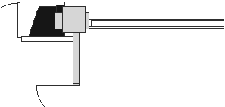 I I G 1 I I 1 ., I I
k·

I I G I I I D I I
D D
T
0 R
3iO ::if

0 )
O

D D

D D D
D D D D D D D
II-----+-----+-_ , D D D D D D D

;;:
..
II-----+-----+--- ,
ig B B B B B B

;! :! :! D D D D D D D

11-----"---+-----'-°+-_ ..,

D D D D D D D D D D D D D D

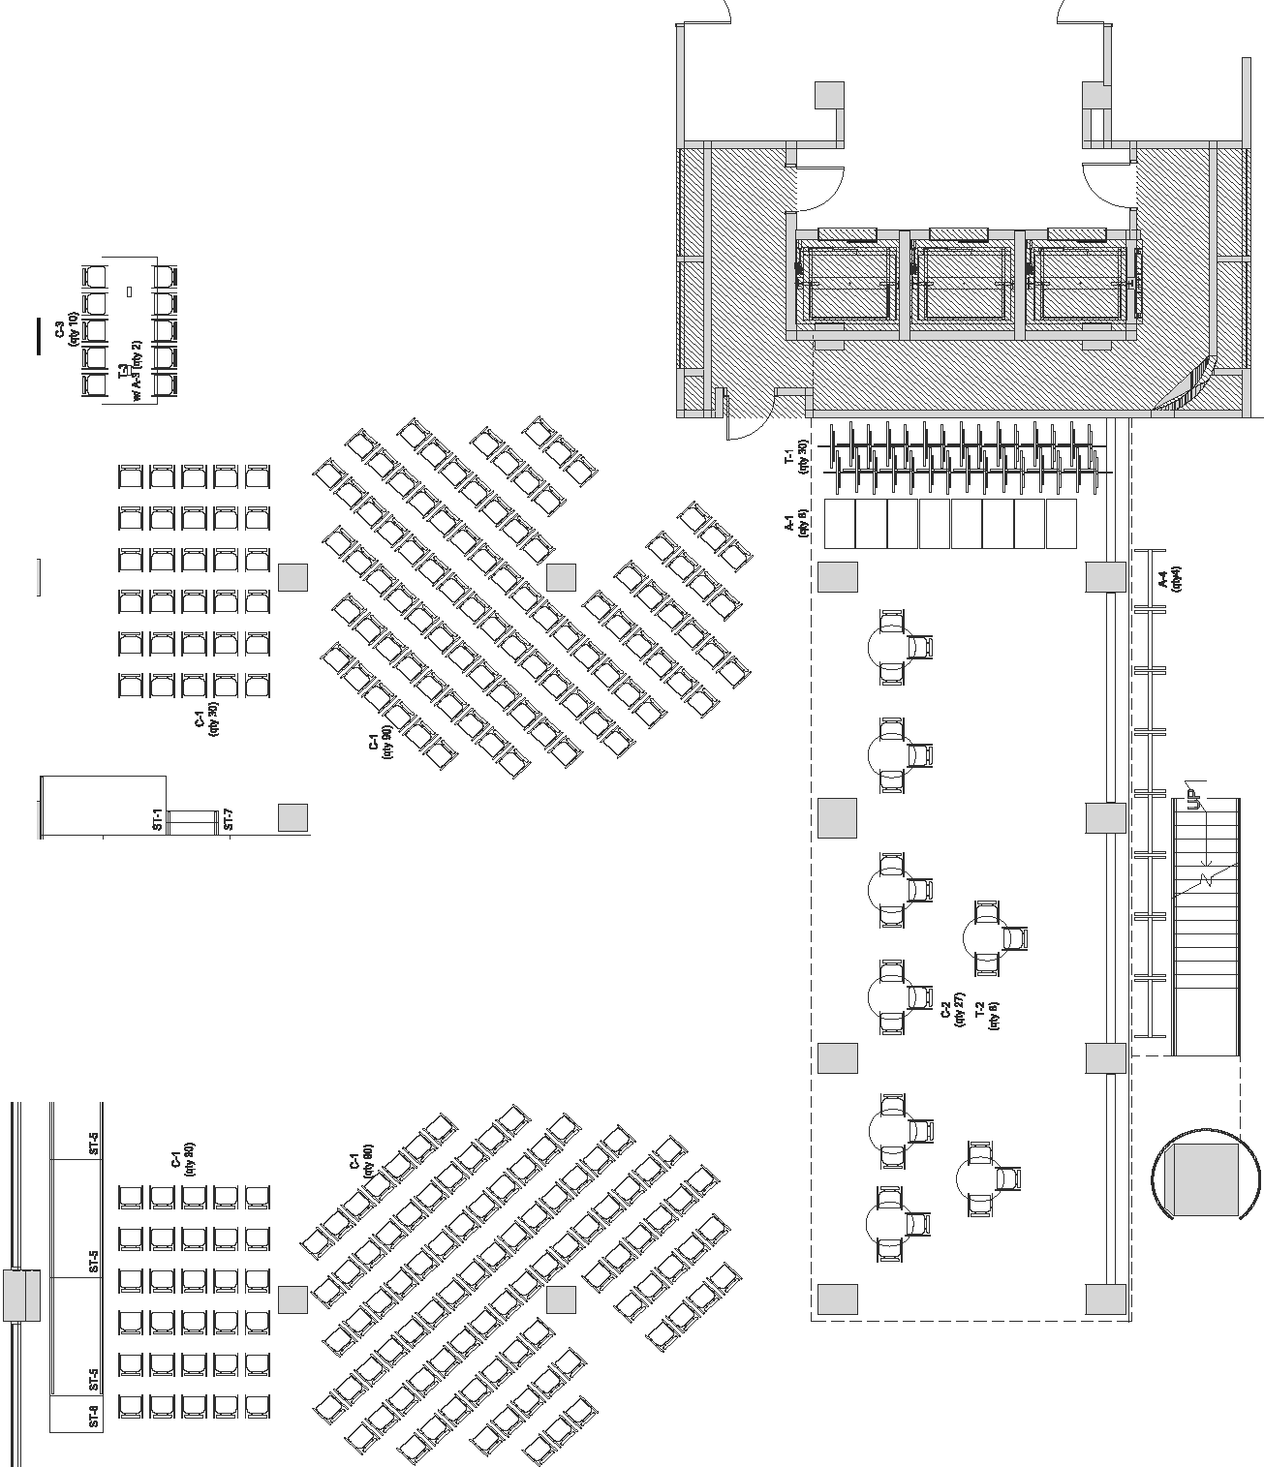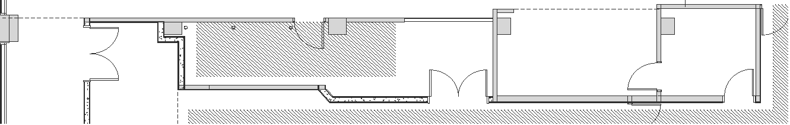....,,,_,--.-------.-- ---r---==;-------' DDDD
D DD D D D

618
S. MICHIGAN
STAGE TWO

SUMMARY
W. VAN BUREN ST.
W. CONGRESS ST.
W. HARRISON ST.
CTA
E. BALBO ST.
W. POLK ST.
W. 8TH ST.

W. 9TH ST.
W. 11TH ST.
W. ROOSEVELT ST.
CTA
S. STATE ST.
S. WABASH ST.
S. MICHIGAN AVE.
Stage TWO is an enclosed multipurpose events space with a stage, full stage lighting, and sound. The space has an open floor plan, making it customizable for many types of events. Appropriate events include concerts, dance, theater, panel discussions, readings, job fairs, conferences, and fashion shows. The Stage TWO lobby area can also be reserved for receptions, registrations, or additional event space in conjunction with a Stage TWO event.
W A B A S H A R T S C O R R I D O R

CAPACITY
183
R
K

HOURS
P
A
Stage TWO is subject to the normal building hours of 623 S. Wabash. Please visit students.colum.edu/space for the most up to date building hours.
G
R
A
N
T

STAGE TWO TECHNICAL SPECIFICATIONS

CONSOLE
Yamaha M7CL-32

CONFIG
32 channel snake, 6 monitor mixes via FOH 6 Microphone Inputs

FOH PROCESSING
(1) Klark Teckik D-360 stereo 31 band graphic EQ (Mains)
(3) DBX 231 stereo 31 band graphic EQ (Monitors)

MAIN SPEAKER SYSTEM
(2) Nexo PS15 (Tops)
(2) Nexo LS1200 (Subs)
(6) Yamaha CM15V (Monitors)
(1) NEXO NXAMP 4x1 Powered TD Controller (Mains)
(3) Crown XLS 802 (Monitors)

MICROPHONES/DIS
SM58s, SM57s, SM81(2), UHF58s (3), Beta 52, Senheiser E604 (3),
Whirlwind IMP passive Dis, Whirlwind pcDI

LIGHTING
ETC SmartFade Lighting Control Unit, Paradigm Architectural Control Processor Dimmer Rack w/ Station Power Module, ETC Source Four Junior, ETC Source Four Par.

HOUSE AV SYSTEM
Art MX622 Mixer
4-channel Shure SCN410 Mixer Tascam CD-200i Sanyo XGA 4000 Lumen Projector

UPSTAGE PROJECTION & SCREEN
Panasonic PT-EZ580U 5400 Lumens (Brightness) ET-ELW20 Zoom Lens (1.3-1.7:1)

STAGE
34’8” X 13’

ADDITIONAL STAGE PIECES
4’ X 6’ X 2’ w/skirting (6 TOTAL)

3’1”

21’8” 10’8”

12’4”

46’7” 34’8” 54’4” wall to wall

34’11”

54’2”
wall to wall

13’
12’6”

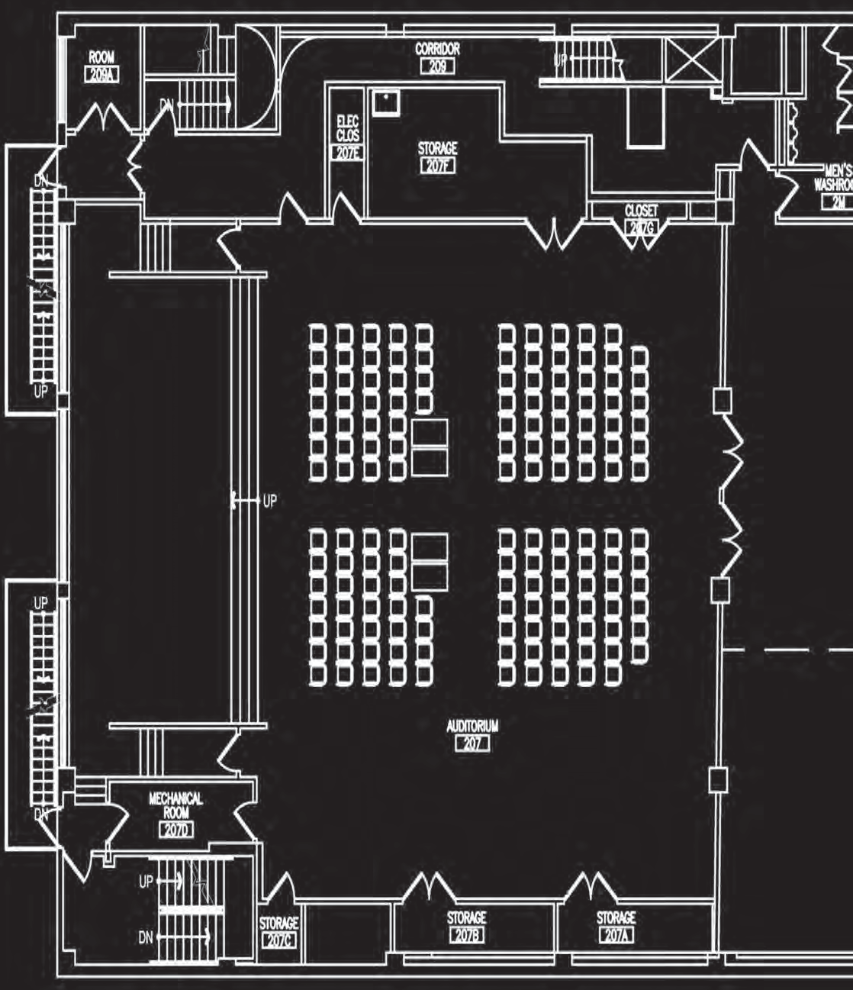

10’9”

11’9”

8’10”
12’3”
Gallery

623
S. WABASH
HAUS:

LOCATED WITHIN THE QUINCY WONG CENTER FOR ARTISTIC EXPRESSION

SUMMARY
W. VAN BUREN ST.
W. CONGRESS ST.
W. HARRISON ST.
CTA
E. BALBO ST.
W. POLK ST.
W. 8TH ST.

W. 9TH ST.
W. 11TH ST.
W. ROOSEVELT ST.
CTA
S. STATE ST.
S. WABASH ST.
S. MICHIGAN AVE.
HAUS, a multi-purpose space located within the Quincy Wong Center for Artistic Expression, functions both as a hangout and study area for students as well as an events space. The room has a small stage and backstage area and was recently renovated to have a nightclub feel. HAUS is best suited for small concerts, comedy acts, and readings.
W A B A S H A R T S C O R R I D O R

Important Note: The HAUS is an open space for students at all times. DEPS does not block the space off for rehearsals, soundchecks, or private events. Please keep in mind that any activities that are planned in this space may be witnessed by members of the Columbia community and that DEPS will not approve requests to block off the space for privacy.
P
A
R
K

CAPACITY
N
T
179
R
A

HOURS
G
HAUS is subject to the normal building hours of 623 S. Wabash. Please visit http://students.colum.edu/space/ for the most up to date building hours.

SETUP
The room currently has 6 two-seater sofas with privacy walls, 18 stools, 18 chairs, 6 high top tables, 6 regular height tables and 3 coffee tables. All tables and chairs can be moved around for event purposes, and it is the responsibility of the event organizers to return all furniture to its original position. No furniture can be added to, or subtracted from the room.

HAUS TECHNICAL SPECIFICATIONS

CONSOLE
Behringer x 32

CONFIG
24 – channel – 4 stage mixes via FOH

FOH Processing (L/R + Mono Side Fill)
Ashley ProTea 3.6SP Digital Loudspeaker Processor QSC GX5 Amplifiers (Tops)
QSC RMX 4050HD (Subs)
Crown XLS402 Amplifiers (Monitors)

MAIN SPEAKER SYSTEM
- Electro Voice ZLX-12 (Tops)
- Electro Voice SB-122 (Subs)
- Yamaha SM10V Two-Way (Monitors)

MICROPHONES/DIS
SM58s, SM57s, MXL603S condenser(2), PG52(1),
IMP passive Dis, Whirlwind pcDI PG56(3),
Whirlwind

LIGHTING
NSI NRD8000 Dimmer Rack, Leviton MC7008 Memory Lighting Controller STAGE DIMENSIONS
18’ W X 15’ DEEP (quarter space circle)

HAUS HOUSE AV SYSTEM SPECIFICATIONS
4 channel Shure SCN410 Mixer
PylePro P2002ABTI Ipod Dock and receiver Yorkville Two-Way transformer speakers (5) Sanyo Pro-xtrX Multiverse Projector (ceiling mounted) 12’L x 7.5 H Da-Lite Projection Screen

STAGE INPUTS
4 channels mic input (XLR) / 1 stereo line channel (1/8” ipod) Video (VGA), Composite (RCA)

STAGE DIMENSIONS
18’ W X 15’ DEEP (quarter space circle)

HAUS HOUSE AV SYSTEM SPECIFICATIONS
4 channel Shure SCN410 Mixer
PylePro P2002ABTI Ipod Dock and receiver Yorkville Two-Way transformer speakers (5) Sanyo Pro-xtrX Multiverse Projector (ceiling mounted) 12’L x 7.5 H Da-Lite Projection Screen

STAGE INPUTS
4 channels mic input (XLR) / 1 stereo line channel (1/8” ipod) Video (VGA), Composite (RCA)

STAGE DIMENSIONS
18’ W X 15’ DEEP (quarter space circle)

BAR COUNTER

ENTRANCE
STAGE
ENTRANCE
ENTRANCE

G
R
A
N
T
P
A

1104
S. WABASH
FILM ROW CINEMA

SUMMARY
W. VAN BUREN ST.
W. CONGRESS ST.
W. HARRISON ST.
CTA
E. BALBO ST.
W. POLK ST.
W. 8TH ST.

W. 9TH ST.
W. 11TH ST.
W. ROOSEVELT ST.
CTA
S. STATE ST.
S. WABASH ST.
S. MICHIGAN AVE.
Film Row Cinema is a multipurpose, multi-room meeting and performance space occupying the 8th floor of 1104 S Wabash. Film Row Cinema encompass- es: Film Row Cinema Theater, Breakout Rooms A, B and C, front lobby, student lounge and student kitchen.
W A B A S H A R T S C O R R I D O R
R
K

FILM ROW CINEMA BREAK-OUT ROOMS A, B AND C

Film Row Cinema theater is Columbia’s largest event and classroom space. Appropriate events for Film Row Cinema include film screenings, lectures and panel discussions.

CAPACITY
Maximum 263 people

SPACE FEATURES
    - Auditorium seating
    - Overhead projector
    - Projection screen
    - Podium

SPACE REGULATIONS
    - Live music is not suitable for Film Row Cinema.

CAPACITY
Maximum 36 people per Break-Out Rooms

SPACE FEATURES
    - Break-Out rooms and B and C are divided by a room divider.
    - Break-Out room is separated from B and C.
    - Each Break-out room contains either a projector and screen or flatscreen.

SPACE REGULATIONS
    - Break-Out rooms are locked unless the space is reserved.
    - A Faculty or staff member must be present for the duration of events hosted in the Break-Out rooms / 8th floor. If a faculty or staff member is not present, the hosting event may lose event privileges.

    - Event planners are responsible for paying for a

DEPS approved projectionist to be present for the duration of events.

    - A Faculty or staff member must be present for the duration of events hosted in Film Row Cinema / 8th floor. If a faculty or staff member is not present, the hosting event may lose event privileges.

LOBBY AND STUDENT LOUNGE

CAPACITY
Maximum 185 people

FURNITURE
    - Lounge furniture (beanbags and couches)
    - 24 – 2’ x 5’ tables

SPACE REGULATIONS
    - For safety reasons, tables and chairs located in the Lobby and Student Lounge must be moved by Campus Facilities.

    - A Faculty or staff member must be present for the duration of events hosted in the Break-Out rooms / 8th floor. If a faculty or staff member is not present, the hosting event may lose event privileges.

HOURS
Events scheduled on the 8th floor are subject to normal building hours found http://students.- colum.edu/space. If the 8th floor is not reserved for an event, the 8th floor is open for students’ use 9am – 5pm. Outside of 9am – 5pm, the 8th floor
is locked.

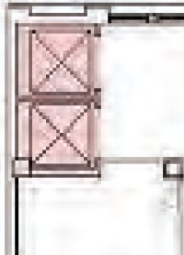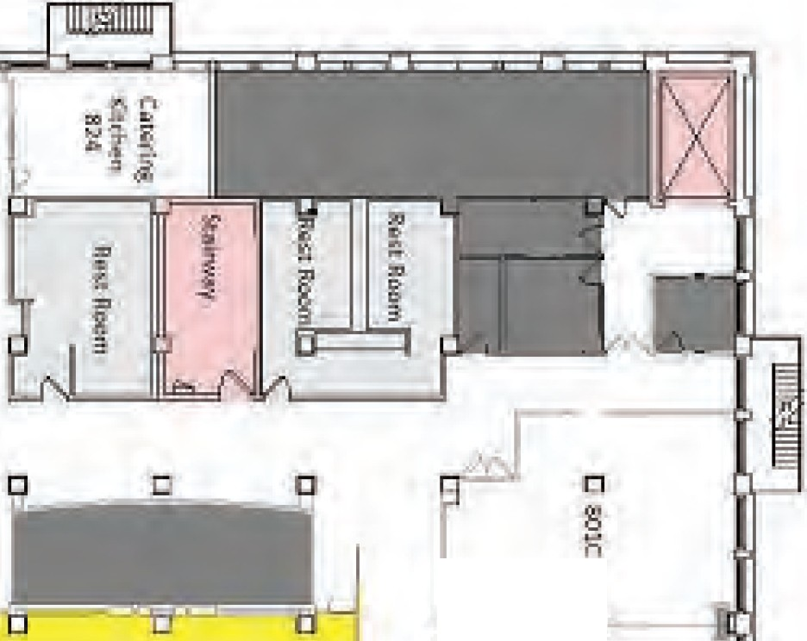

[]

STEP
4
RESERVE YOUR SPACE &
REQUEST RESOURCES

- CHECK SPACE AVAILABILITY
You can check for campus space availability through Space Scheduler at space.- colum.edu. Students can login using their OASIS ID. Spaces fill up quickly! Try to do this far in advance.

- RESERVE YOUR SPACE!
Space requests should include as much information as possible, including: Reservation time
This is the total time you will be in the space including set-up, event time and clean-up
Expected attendance
Event needs should include:
- Number of tables and chairs needed
- A floor plan with furniture layout. (See example floor plan at end of this section.)
- Tech needs such as backline, microphones, projectors, etc. o Trash removal, recycling and composting needs:
  - If you are serving food, Facilities must be informed for proper
trash removal.
  - Make conscious decisions while event planning to become a “Green Seal” event!
- Event summary
  - Use the description from Step One! This will give everyone who supports your event an idea of what to expect.

ROOM SET-UP SUPPORT
If you do not know your set-up needs when reserving the space, you can put a note in the reservation that you will email Andrew Dupuis (adupuis@colum.edu) with set-up needs no later than 2 weeks before your event.

TECHNICAL NEEDS SUPPORT
If you do not know your tech needs when reserving the space, you can put a note in the reservation that you will email Ted Cho (tcho@colum.edu) with tech needs no later than 2 weeks before your event. If less than 2 weeks notice is provided, AV assistance is not guaranteed.

Review the Space
Scheduler Instructions and Sustainability Checklist at the end
of this section.

IMPORTANT INFORMATION ABOUT AV/TECH
Only DEPS AV technicians are permitted to operate DEPS sound and lighting equipment. For DEPS Spaces (Conaway Center, HAUS, Stage Two, and Film Row Cinema); AV technicians are free of charge for student sponsored events (individual student events and student organizations) from 9am – 5pm.

After-hour tech fees for the 2016-2017 academic year are as follows: o Weekdays, after 5pm $18/hour
o Weekends, $20/hour

There is a three-hour minimum for all weeknight and weekend tech fees.

If event or use of AV technician is cancelled, a 48-hour notice must be given or event organizers will be charged the three-hour tech minimum fee.

For students not associated with a class or student organization, fill out the “Faculty and Staff Event Support Agreement” located at end of this section
and submit to deps@colum.edu four weeks before
you event.

FACULTY/STAFF SUPPORT FOR STUDENT-RUN EVENTS

STUDENT NAME: EVENT NAME (OR CLASS ASSIGNMENT): EVENT DATE & TIME: EVENT LOCATION: SUPPORTING STAFF/FACULTY MEMBER: SUPPORTING STAFF/FACULTY EMAIL: STAFF/FACULTY DEPARTMENT (INCLUDE COURSE NAME IF APPLICABLE):

Thank you for agreeing to serve as the supporting sponsor for my event.

I am working with the Department of Exhibition and Performance Spaces to finalize event details. The event has been conditionally scheduled pending receipt of this contract.

I am committed to the execution and success of the event. I accept the responsibility for planning, setup, cleanup, talent management, promotion and general event management of the event. If applicable, I am also responsible for paying event fees (AV tech support, additional security and general event production costs). Most importantly, I agree to be respectful of the event space and equipment, and to adhere to Columbia College Chicago’s Student Code of Conduct.

As the support staff sponsor, your role is to attend the event, serve as a representative of the College and provide professional guidance as needed. Should you observe that campus rules are being violated during an event, please alert securitywho will assess and handle the situation.

STUDENT SIGNATURE
DATE

SUPPORTING STAFF/FACULTY MEMBER
DATE

SUSTAINABILITY GUIDELINES

Columbia College Chicago is committed to sustainability! Use the guidelines below to ensure you are hosting a sustainable event and taking care of our earth!

CATERING
Beverages supplied in carafes, cambros, decanters No Styrofoam provided
Paper Products used in place of Styrofoam or Polystyrene (#6) plastics Small, reusable pitcher/dispenser (for condiments, creamer, etc.) provided
Single serving items (silverware, stirrers, straws, condiments, etc.) minimized Food served buffet-style
Food served on returnable trays or in baskets Reusable service ware provided (china, glassware) Linen service provided
Food quantities equivalent to expected guests Recyclable service ware (cups, bowls) provided
Compostable service ware provided (paper cups, paper plates, uncolored napkins) Catering delivery packaging limited
Unbleached/chemical free napkins provided Local/sustainable food options offered Vegetarian/Vegan food options offered Compost collection during event

EDUCATION
Event staff on hand to educate and aid patrons with recycling/composting Outside caterers/vendors follow campus recycling/composting guidelines

PROMOTION
Print reasonable quantity of materials
Printing on recycled content paper (>30% content)
Event promoted virally (email lists, department website, etc.) Post-event removal of flyers on campus
All unused print materials recycled No foam board used
Evergreen Print Signage (has no dates/times, can be used again)

HOW TO SUBMIT A SPACE REQUEST

STEP 1: Log in to the space.colum.edu site using your Oasis Login.

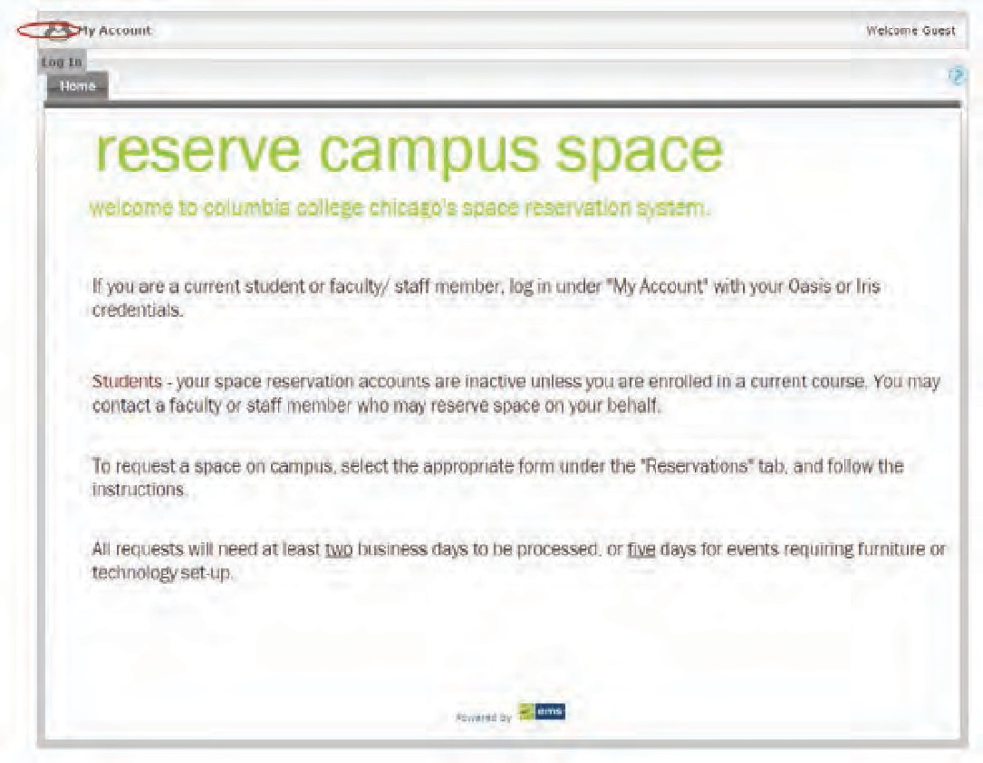

STEP 2: Click the “Reservations” tab and make a selection.
- Select “Student-Book a space for events” if you are an individual student looking to reserve space
e.g. rehearsal space, study groups, small meetings etc. Please note that depending on the nature of the event, a faculty/staff host may be required.

- Select “Student-Book a space for film shoots” to film in a space on campus. If your request requires shooting video footage of any kind, please select this option.

- Select “Student-Book a space for student org functions” if you are a member of a student organization and are requesting space on behalf of the org. All student org functions will be verified by the faculty/staff advisor of the organization.

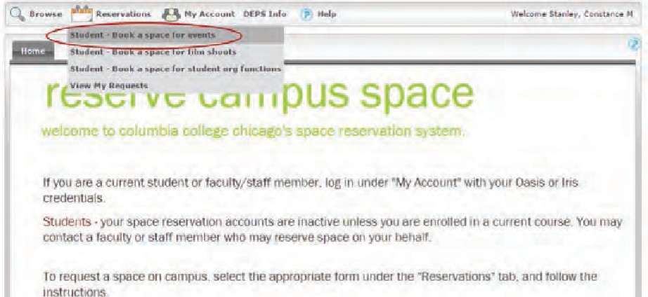

STEP 3: Fill-out the fields on the left side of the page as indicated by the arrows.

When and Where: Date, Start Time, End Time, Facilities
Setup Information: Attendance(Indicate the number of attendees)
Availability Filters: Room Type(Select the type of room needed for your event e.g. classroom, lobby, meeting, computer lab etc.)
Features: (Select the features needed for your event e.g.projector, mic, scanner etc.)

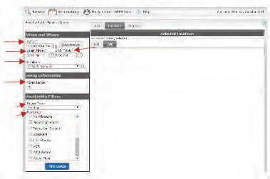

STEP 4: Click the “Find Space” button. Click on the “Location” tab and select
the room of choice.
You have now selected your space!

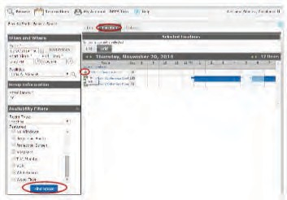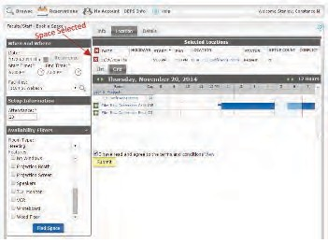

STEP 5: Click the “Details” tab and fill-out ALL of the information underneath each field as indicated by the arrows. To proceed to Step 6, all fields with an * must be completed.

STUDENT ORGS: Please provide the faculty/staff advisor for your student org as the “2nd Contact”.

STUDENTS: If your space reservation is pertaining to an academic course, please provide the instructor of the course as the “2nd Contact”.

Check the “I have read and agree to the terms and conditions” box at the bottom of the page and Click the “Submit” button.

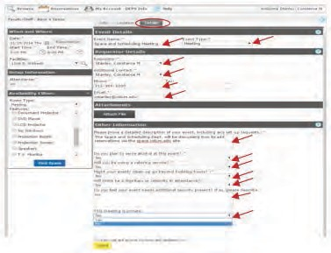

Once the request has been submitted, this confirmation box will appear. CONGRATULATIONS! Your reservation request is now complete.

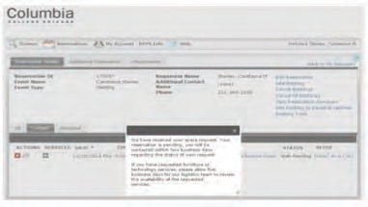

NOTE: If the space you are looking to select is not an option, you are welcome to ask a faculty/staff member to book the space on your behalf. e.g. DEPS spaces, Film Row, screening rooms etc.

To confirm that your request was submitted, click the “Reservations” tab and select, “View My Requests”.

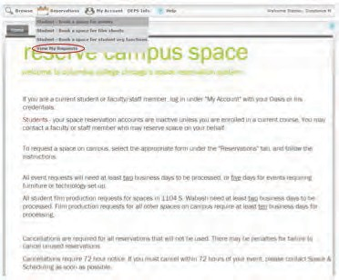

The “Web Pending” status indicates that your request has been received.

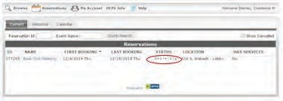

The requestor will receive an e-mail stating that Space and Scheduling has received your space request. If there are any questions or discrepancies with your reservation, Space will send you a follow-up e-mail for more details. Please be sure to respond in a timely fashion as the scheduling of your event may be adversely affected. Once the space is approved, the requestor will receive a Confirmation e-mail.

SAMPLE STAGE PLOT: NEW STUDENT CONVOCATION 2015

FPC
BFOA
+ FPC
BFOA
+ FPC
VOX 6

5 PIECE DRUMS
5
BFOA
+ FPC

GTR 1
GTR 2

BASS AMP

GTR 3

KEYS AMP

BFOA

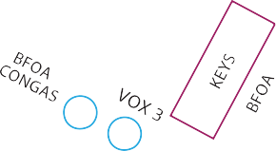VOX 2 VOX 4 VOX 5

VOX 1

4

2

4
1

NOTES

= MONITORS (5 MIXES)

BFOA VOX= 2,3,4

FPC VOX= 2,3,4,6

Please provide at least 3 quad power outlets along down stage and at least 4 along up stage.

BAND #1

NAME CONTACT

BAND #2 NAME
CONTACT

BAND #3

NAME CONTACT

SAMPLE FLOOR PLAN

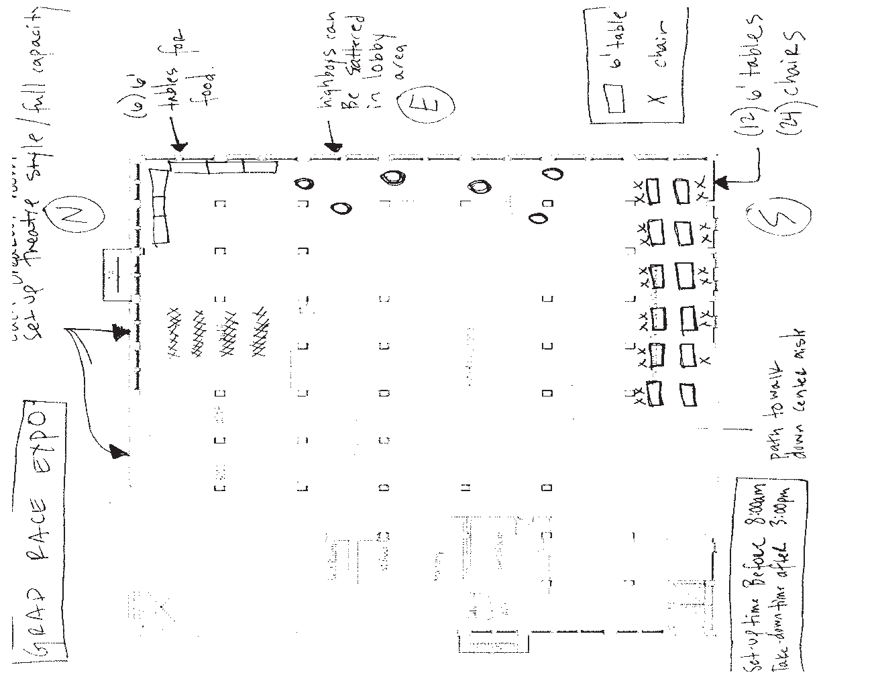

STEP
5
ADDITIONAL REQUESTS

In addition to your space reservation requests, you might need additional resources to host your event.

BUILDING HOURS - $144/HOUR

All events must be completed with all event organizers and attendees out of the building by the scheduled building closing time. Building hours can be extended with 3 weeks advance notice. An advisor must be present at any event requiring a building extension.

If you fail to have a request submitted and approved three weeks in advance, the Office of Safety & Security will charge you double the standard fee.

EXTRA SECURITY - $35/HOUR

Your event may require additional security, especially if a large crowd is expected or if you are bringing a high profile guest. The Office of Campus Safety
& Security will determine the number of guards needed for your event. You will be required to pay all extra security guards. You and your advisor should schedule a meeting with them before your event.

STUDENT ORGANIZATIONS AND LEADERSHIP EVENT SUPPLIES AND EQUIPMENT

SOL has various event management supplies and equipment that may be checked out at no charge for your events. All requests must be made 3 weeks before your event. Contact Student Organizations & Leadership at leadership@colum.edu.

- 4x 4 Stage pieces, can be elevated to 16 or 24 inches.
(39) Walkie Talkies
(6) Stanchions
(10) I-pads
(2) Popcorn machine
(1) Cotton candy machine
(1) Bubble Machine
(1) Portable PA and Microphone.
(1) Red Carpet
(1) Step and Repeat Various decorations
53lbs, 500 Stereo Watts, Eight-input mixer: six mic/line, two mono/stereo, Tape Out (Dual RCA® jacks) with level control, and 35mm (1 3/8”) Stand Adapters are built into speaker cabinets.

STEP
6
CREATE A MARKETING PLAN

A marketing plan is a written blueprint that outlines your project's overall marketing efforts. The sections below are common components of a marketing plan that will help you think through how to promote your event.

SITUATION ANALYSIS
This is an overview of your current situation and is a starting point as you develop your plan. You can create a bullet-point SWOT analysis. As you plan your event, consider what are your: Strengths and Weaknesses (internal) and Opportunities and Threats (external). Here is an example SWOT analysis:

OPPORTUNITIES (EXTERNAL)
Campus partnerships New audience
Enhance sponsor involve- ment

THREATS (EXTERNAL)
High competition Bad weather Date/time conflicts Budget cuts

STRENGTHS (INTERNAL)
Experienced team High motivation level
Strong social media following Strong brand name

WEAKNESSES (INTERNAL)
Complicated processes Week brand name Volunteer recruitment

TARGET AUDIENCE
Who is interested in your event? Create a bulleted description of characteristics of your targeted audience. Is there a specific major that might interested in your event? Do they live on or off campus? Are they freshmen who interested in joining new groups?

GOALS
Make realistic and measurable goals for your event. Do you want to increase the number of freshmen in attendance at your event? Do you want to improve the number of people or groups you are collaborating with? Do you want to recruit a certain number of new volunteers? Do you want to raise a certain amount of dona- tions at your event?

GOALS, STRATEGIES AND TACTICS
This is the plan the addresses the goals you just set. Tactics might include print, ads, social media, guerilla marketing, class visits. Be sure to create a schedule of implementation! For example:

Goal - Our goal is to improve attendance among freshmen by 10%.
Strategy - Freshmen will receive a benefit (free merch/prizes/etc) at our event. Tactic – We will work with RAs to distribute handbills within the dorms.
Tactic – We’ll hold a lobby day in The Court to talk one-on-one with students. Tactic – We’ll have a flash mob with RHA in front of dorms.

Consider using campus resources within your marketing plan.

CAMPUS EVENT CALENDAR
Post your event to the campus event calendar at http://events.colum.edu. This will allow students to see it on the Columbia Events app.

STUDENT COMMUNICATIONS
StuCom offers graphic design services for print material, event photographers/ videographers and email/social media promotion. Distribute your posters and handbills throughout campus. Make requests 4 weeks in advance. Find the online forms here to make a request:

colum.edu/stucom

CREATING PROMOTIONAL MATERIALS WITH STUCOM
Create clarity about what your event has to offer! Make sure your promotional materials include the following in your initial request:
Who: Who is sponsoring the event? What: What is the event?
Where: Where is the event? When: When is the event?
Why: Why is this event important?
How: How can others get more information?

POSTING
There are designated areas where you can post information about your events. Your organization is responsible for removing promotional materials after the event takes place. If you would like to post in the Residence Halls, contact Residence Life located at 731 S. Plymouth Court.

LOBBIES
Designated lobbies can be reserved for fundraising, recruiting, promoting, etc. can be reserved through the Campus Space Scheduler (see Step Four).

FREQUENCY TV
Think about potential partnerships with our campus tv station for short features. Contact Chris West for inquiries at cwest@colum.edu.

Refer to the Campus Poster Distribution list at the end of this section for approved
locations.
THE CHRONICLE
Consider placing advertising in The Chronicle for events. Visit for more info: www.columbiachronicle.com/more/advertise. Pitch a story about your event – allow 2 weeks! Contact chronicle@colum.edu or call 312-369-8999.

WCRX 88.1FM CAMPUS RADIO STATION
Submit your Public Service Announcements to WCRX FM. WCRX serves the interests of the community. Send your event information at least 3 weeks in advance to: WCRX Radio Public Service Department at wcrxdj@colum.edu

SOCIAL MEDIA
Facebook, YouTube, Twitter, Flickr, Instagram, Blogs are all great ways to show and tell people
who your organization is and the great things you are doing.

EMAIL
Put your contacts to use! Set up an automatic reply on your general organization e-mail address so that you can connect with members and prospects, and let them know you care about their participation. Send out reminders emails 2 weeks out, 1 week out, 1 day out, and day of event.

ACADEMIC DEPARTMENTS
Does your target audience tie in well with an academic department? For example, are you featuring a film screening you think film students would want to attend? Or maybe you are hosting a fashion show and think the Fashion Department could promote to their students?

Contact the Assistant to the Chair (in the campus directory) within academic departments to inquire about how to promote your event to their students. Ask if they have newsletters, a location for announcements or if you can do class visits.

WORD OF MOUTH
Think of an elevator pitch. Most elevator rides aren’t that long so you want to be able to pitch your event information quickly. Make sure all of your members can describe what you do in a consistent manner.

Student Organizations should visit “Marketing Your Organization” section of the Student Organizations & Leadership Handbook for information on promoting your events.

POSTER DISTRIBUTION LIST - TAKE ONE WITH YOU FOR POSTING

623 S. WABASH

All floors at eye level Lobby/Stairwells 1-3
3rd floor: All departments
Postcard rack in Hokin Gallery

600 S. MICHIGAN

All floors & Stairwells 1-5

618 S. MICHIGAN

All floors by elevators except 3rd floor

624 S. MICHIGAN

All floors & stairwells 1-3 & 6, 7, 8
7th floor Computer Lab (Small Flyers) 8th floor Computer Lab (Small Flyers) 11th floor Lounge (Table Tents) Library (ask if possible)

33 E. CONGRESS

All floors
3rd floor Lounge
South Basement (Small Flyers) 4th floor Senior Seminar
7th floor Sound Department
Postcard Rack

916 S. WABASH

1st floor Lobby

1104 S. WABASH

1st floor posting board in Conaway Center Front and back elevator banks
Ask permission at the 3rd floor main Film office for 3rd, 4th, 5th, 6th, and 7th floors.

1014 S. MIGHIGAN

All floors
3rd floor Student Lounge

72 E. 11TH ST.

Get approval stamps from main office on 3rd floor
Basement 2nd, 4th, 5th, & 6th flloors

1415 S. WABASH

1st floor

1306 S. WABASH

All floors & Dance Lounge

731 S. PLYMOUTH

Drop 75 posters at the main office

STEP
7
CREATE A PRODUCTION PLAN

It’s important to plan how you will manage your time and resources the day of an event from set-up to clean up.

Has your team scheduled tasks for the day?
Have you scheduled time for a sound check before your event? Does your talent know their call-time?
Does the caterer know where to park and when to bring food? Do you have all the supplies you need?
Tape to hang decorations? A bin to hold ice?
Extension cords?
Have you allowed enough time for clean-up before the building closes?

Thinking about details like these will help your event run much more smoothly and limit any last minute panicking!

Two weeks before your event, create a detailed production schedule that lists each task that needs to be completed, what time it should be done and who is responsible. Always have a list of contact info with cell phone numbers just in case. Have a meeting with your team to make sure everyone is aware of their responsibilities during your event.

SUGGESTION: Do a walkthrough before and after your event with your team. Make sure you don’t leave anything behind or it will be discarded.

Use the Sample Production Schedule at the end of this section
as a guide.

SAMPLE DAY-OF PRODUCTION SCHEDULE

DAY | TASK | STAFF CONTACT | LEAD CONTACT PHONE | BUILDING
6:30 A.M. | Building Extension: Unlock early | Security | Name/312.XXX.XXXX | 1104
6:30 A.M. | Production Staff report time | Production Staff | Name/312.XXX.XXXX | 1104
6:45 A.M. | Catering staff report time | Catering Company | Name/312.XXX.XXXX | 1104
7:00 A.M. | Tables and chairs set-up | Facilities And Operations | Name/312.XXX.XXXX | 1104
7:00 A.M. | Composting and Recycling set-up | Sustainability | Name/312.XXX.XXXX | 1104
7:15 A.M. | Event decorations complete | Production Assistant | Name/312.XXX.XXXX | 1104
7:30 A.M. | AV/Tech in place for musicians, projector ready and microphone set-up for speaker on stage | Department Of Exhibition And Performance Spaces | Name/312.XXX.XXXX | 1104
7:30 A.M. | Set-up building flags and signage in lobby | Production Assistant | Name/312.XXX.XXXX | 1104
7:30 A.M. | Move bags and check-in supplies to 1104 | Production Assistant | Name/312.XXX.XXXX | 1104
7:30 A.M. | Event fully staffed | All Staff On Duty | Name/312.XXX.XXXX | 1104
7:30 A.M. | Musicians arrive for set-up | Musicians | Name/312.XXX.XXXX | 1104
7:45 A.M. | Photographer arrives | Photographer Name | Name/312.XXX.XXXX | 1104
6:30 A.M. | Musicians begin | Musicians | Name/312.XXX.XXXX | 1104
7:45-9:30 A.M. | Guest Check-In station | Production Assistant | Name/312.XXX.XXXX | 1104
7:45 A.M. | Musicians begin | Musicians | Name/312.XXX.XXXX | 1104
8:00 A.M. | Event begins
8:20-8:30 A.M. | Guest speaker greetings | Guest Speaker | Name/312.XXX.XXXX | 1104
8:20-8:30 A.M. | Musicians on break | Musicians | Name/312.XXX.XXXX | 1104
9:00 A.M. | Event ends
9:00 A.M. | Take down decorations, flags and signage | Production Assistant | Name/312.XXX.XXXX | 1104
9:00 A.M. | Catering strike | Catering Company | Name/312.XXX.XXXX | 1104
after 9:00 A.M. | Catering Clean-up | Facilities And Operations | Name/312.XXX.XXXX | 1104
after 9:00 A.M. | Recycling and Composting clean-up | Sustainability | Name/312.XXX.XXXX | 1104
after 9:00 A.M. | Take down tables and chairs | Facilities And Opearations | Name/312.XXX.XXXX | 1104
after 9:00 A.M. | Return event supplies to 623 | Production Assistant | Name/312.XXX.XXXX | 1104

STEP
8
WRAP UP/EVALUATION

Conclude your event with an evaluation. This will help your team with planning events in the future. There are several ways to evaluate the success of your program. Always refer back to the goals you set within your marketing plan.
There might be things you can do during your event - such as keeping attendance or collecting emails at check-in that will assist with your event evaluation.

As a team consider the following questions:

Should this event be repeated in the future? Were the goals of the event met?
What went well during the event? What can be improved upon?
What ideas/suggestions do you have for future events?

Simple surveys for both the event planning team, as well as your guests can also assist with your evaluation. Consider using iAttend to capture emails at the door so you can email them after the event.

USEFUL CONTACT INFORMATION

Feel free to contact any of the people below to assist with the planning of your event. They are here to help. And of course, your advisor will be your main support when planning your event!

Conaway Center, Stage TWO, HAUS, Film Row Cinema
Facilities and Events Coordinator deps@colum.edu

AV Technical Requirements
Ted Cho
Technical Coordinator tcho@colum.edu

Cleaning, Recycling and Composting
Michael Dunham
Facilities and Operations Manager mdunham@colum.edu

Student Organizations & Leadership, The Loft
Loft Assistants leadership@colum.edu
Space Set-Up
Andrew Dupuis
Events Reservation Assistant adupuis@colum.edu

Space Scheduler Assistance
Constance Stanley
Space and Scheduling Coordinator cstanley@colum.edu

Safety and Security
Charrisse Musgrove
Campus Safety and Security Coordinator, cmusgrove@colum.edu

DEADLINE REMINDERS

The sooner you do all your tasks, the better off you will be! However, use the deadlines below as a guide to planning your event and submitting all necessary requests on time to ensure a successful event.

4 WEEKS:

4 WEEKS:

4 WEEKS:

3 WEEKS:

3 WEEKS:

3 WEEKS:

3 WEEKS:

2 WEEKS:

2 WEEKS:

2 WEEKS:

2 WEEKS:
Space Reservation

Faculty and Staff Event Support Agreement (If not associated with a student org) Student Communications poster/postcard requests
Building Extensions (through your advisor) Extra Security (through your advisor)
Event supplies and Equipment Request with Student Organizations & Leadership PSA’s with WCRX 88.1FM
Furniture/Space Set-Up (If not in your initial space request)

Clean-Up/Recycling/Composting (If not in your initial space request) Technical Requests (If not in your initial space request)
Ads and Stories with The Chronicle

